**(SRS)**

LED String Animation

Contents

**1.** **Document History** 3

**1.1.** **Revision History Table** 3

**1.2.** **Current** **Document** **Status** 3

**2.** **Project Description** 3

**3.** **Block Diagram** 4

**4.** **Feature Description** 5

**4.1.** **Start Up Requirements** 5

**4.2.** **Tail Function Requirements** 8

**4.3. Turn Indicator (TI) Requirements** 10

**5.** **Reference Documents Table** 13

# **Document History**

## **Revision History Table**

|  |  |  |  |
| --- | --- | --- | --- |
| Version | Author | Date | Change |
| 1.0 | Hesham - Mahmoud Gamal - Mark | 06/02/2020 | Initial Creation |
| 1.1 | Hesham - Mahmoud Gamal | 20/02/2020 | * Document Name changed. * Adding tables for all requirements. * Removing redundant requirements. * Updating revision history table, status table and reference tables. |

## **1.2 Current Document Status**

|  |  |  |  |
| --- | --- | --- | --- |
| Version | Status | Author | **Date** |
| 1.0 | Draft | Hesham - Mahmoud Gamal - Mark | 06/02/2020 |
| 1.1 | Draft | Hesham - Mahmoud Gamal | 20/02/2020 |

# **Project Description**

The project is composed of 3 sets of LED Strings Simulating the animation of LEDs in a Car, One set is named “Tail” and it simulates the animation of car’s back LEDs while the other 2 sets are named “Left TI” and “Right TI” is simulating the animation of left and right turn indicator in a car.

Each one of the 3 functions operates based on input signals coming from 3 switches named “Tail Switch”, “Left TI” and “Right TI” respectively in addition to “Welcome Mode” which shall operates one of 2 different modes based on the status of the mode switch. System layout is as shown in **Figure 1** below.

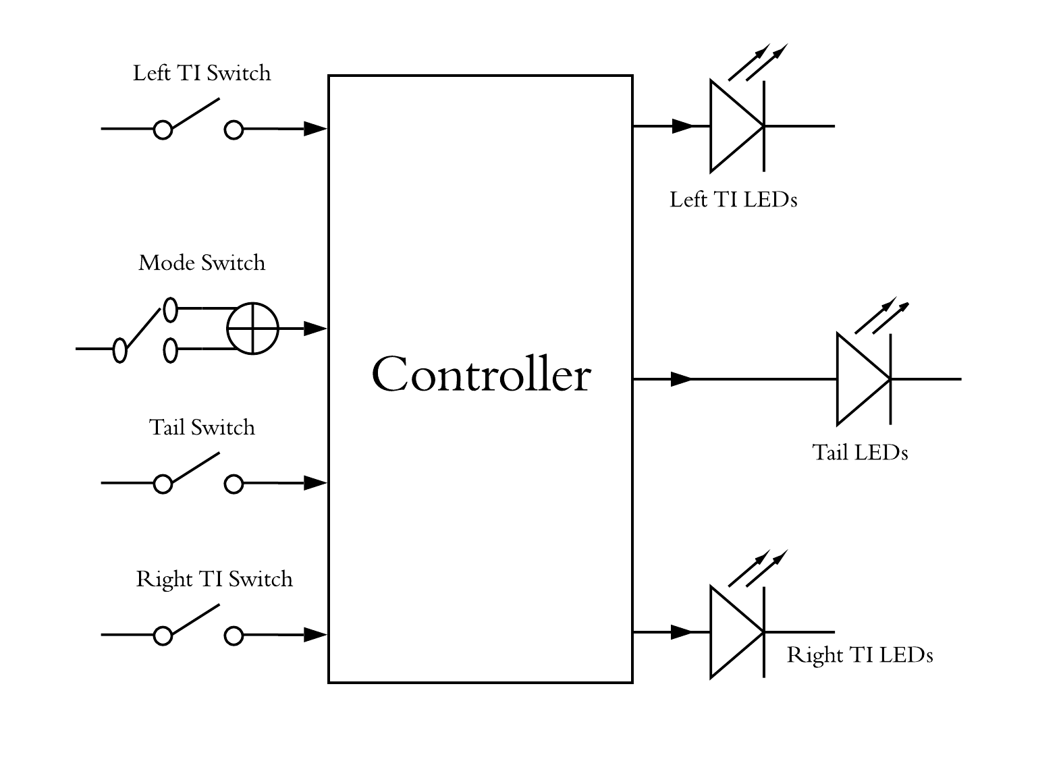

Figure 1: layout of the system

# **Block Diagram**

The following **Figure 2** is describing the block diagram of the overall system.

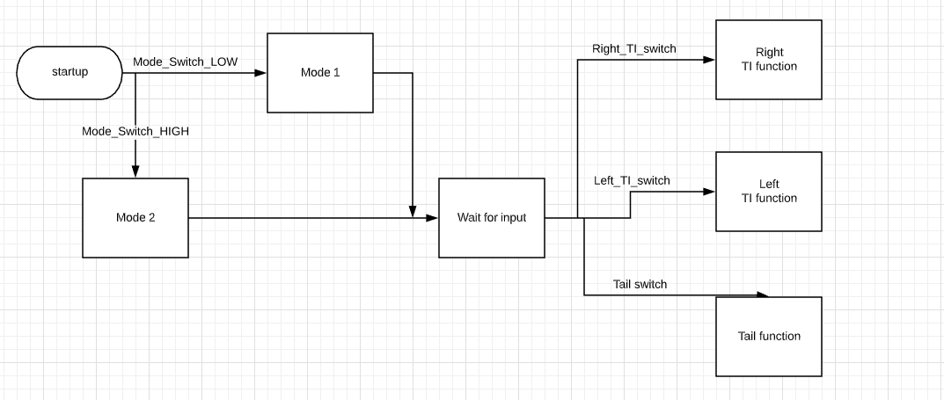

Figure 2: Block Diagram of overall system

# **Feature Description**

## **Start Up Requirements**

|  |  |  |  |
| --- | --- | --- | --- |
| Req_ID | Req_ PO5_LSAN_ SRS_Start welcome mode 1/2_01-V02 | Covers | Covers_ PO5_LSAN_ CYRS_01_V01  Covers_ PO5_LSAN_ CYRS_02_V01 |
| Description | SW shall read the mode switch status. | | |
| Inputs | Mode-Switch-connected pin value (High/Low). | Outputs | Switch Status (Pressed/Released). |
| Test Scope | ITD/VTD | | |
| Author | Hesham – Mahmoud Gamal | Date | 20/02/2020 |

|  |  |  |  |
| --- | --- | --- | --- |
| Req_ID | Req_ PO5_LSAN_ SRS_Start welcome mode 1_01-V02 | Covers | Covers_ PO5_LSAN_ CYRS_01_V01 |
| Description | SW shall set flag to TRUE to start the MODE 1 function if the switch is pressed. | | |
| Inputs | Mode Switch Status (Pressed). | Outputs | Mode Switch Flag (TRUE). |
| Test Scope | ITD/VTD | | |
| Author | Hesham – Mahmoud Gamal | Date | 20/02/2020 |

|  |  |  |  |
| --- | --- | --- | --- |
| Req_ID | Req_ PO5_LSAN_ SRS_Start welcome mode 1_02-V02 | Covers | Covers_ PO5_LSAN_ CYRS_01_V01 |
| Description | SW shall start **MODE 1** which is to switch on the 12 pins one by one from L6 to L1, then from R1 to R6 and vice versa. Then they all should switch on and off. A small delay of **200 ms** shall be inserted between each change to be noticeable and smooth. | | |
| Inputs | Mode Switch Flag (TRUE). | Outputs | LEDs Welcome Mode1 is activated. |
| Test Scope | ITD/VTD | | |
| Author | Hesham – Mahmoud Gamal | Date | 20/02/2020 |

|  |  |  |  |
| --- | --- | --- | --- |
| Req_ID | Req_ PO5_LSAN_ SRS_Start welcome mode 2_01-V02 | Covers | Covers_ PO5_LSAN_ CYRS_02_V01 |
| Description | SW shall reset flag to FALSE to start the MODE 2 function if the switch is released. | | |
| Inputs | Mode Switch Status (released). | Outputs | Mode Switch Flag (FALSE). |
| Test Scope | ITD/VTD | | |
| Author | Hesham – Mahmoud Gamal | Date | 20/02/2020 |

|  |  |  |  |
| --- | --- | --- | --- |
| Req_ID | Req_ PO5_LSAN_ SRS_Start welcome mode 2_02-V02 | Covers | Covers_ PO5_LSAN_ CYRS_02_V01 |
| Description | SW shall start **MODE 2** which is to switch on the 12 pins one by one from L1 to L6, simultaneously with R1 to R6. Then repeat this scenario again. A small delay of **200ms** shall be inserted between each change to be noticeable and smooth. | | |
| Inputs | Mode Switch Flag (FALSE). | Outputs | LEDs Welcome Mode2 is activated. |
| Test Scope | ITD/VTD | | |
| Author | Hesham – Mahmoud Gamal | Date | 20/02/2020 |

## **Tail Function Requirements**

|  |  |  |  |
| --- | --- | --- | --- |
| Req_ID | Req_ PO5_LSAN_ SRS_Tail function(ON/OFF)_01-V02 | Covers | Covers_ PO5_LSAN_ CYRS_03_V01  Covers_ PO5_LSAN_ CYRS_04_V01 |
| Description | SW shall read the tail switch status. | | |
| Inputs | Tail-Switch-connected pin value (High/Low). | Outputs | Tail Switch Status (Pressed/Released). |
| Test Scope | ITD/VTD | | |
| Author | Hesham – Mahmoud Gamal | Date | 20/02/2020 |

|  |  |  |  |
| --- | --- | --- | --- |
| Req_ID | Req_ PO5_LSAN_ SRS_Tail function ON_01-V02 | Covers | Covers_ PO5_LSAN_ CYRS_03_V01 |
| Description | If the signal is HIGH, then Tail flag shall be set to TRUE. | | |
| Inputs | Tail Switch Status (Pressed). | Outputs | Tail switch Flag (TRUE). |
| Test Scope | ITD/VTD | | |
| Author | Hesham – Mahmoud Gamal | Date | 20/02/2020 |

|  |  |  |  |
| --- | --- | --- | --- |
| Req_ID | Req_ PO5_LSAN_ SRS_Tail function ON_02-V02 | Covers | Covers_ PO5_LSAN_ CYRS_03_V01 |
| Description | If the Tail flag has been set to TRUE, then Tail Pins shall be activated. | | |
| Inputs | Tail witch Flag (TRUE). | Outputs | Tail LEDs activated (ON). |
| Test Scope | ITD/VTD | | |
| Author | Hesham – Mahmoud Gamal | Date | 20/02/2020 |

|  |  |  |  |
| --- | --- | --- | --- |
| Req_ID | Req_ PO5_LSAN_ SRS_Tail function OFF_01-V02 | Covers | Covers_ PO5_LSAN_ CYRS_04_V01 |
| Description | If the signal is LOW, then Tail flag shall be set to FALSE. | | |
| Inputs | Tail Switch Status (released). | Outputs | Tail witch Flag (FALSE). |
| Test Scope | ITD/VTD | | |
| Author | Hesham – Mahmoud Gamal | Date | 20/02/2020 |

|  |  |  |  |
| --- | --- | --- | --- |
| Req_ID | Req_ PO5_LSAN_ SRS_Tail function OFF_02-V02 | Covers | Covers_ PO5_LSAN_ CYRS_04_V01 |
| Description | If the Tail flag has been set to FALSE, then Tail Pins shall be deactivated. | | |
| Inputs | Tail witch Flag (FALSE). | Outputs | Tail LEDs deactivated (OFF). |
| Test Scope | ITD/VTD | | |
| Author | Hesham – Mahmoud Gamal | Date | 20/02/2020 |

## **4.3. Turn Indicator (TI) Requirements**

|  |  |  |  |
| --- | --- | --- | --- |
| Req_ID | Req_ PO5_LSAN_ SRS_Right Turn Indicator On_01-V01 | Covers | Req_ PO5_LSAN_ LED STRING ANIMATION_05_V01 |
| Description | SW shall read the right TI switch pin status. | | |
| Inputs | TI Switch Status (Pressed). | Outputs | Start Function |
| Test Scope | ITD/VTD | | |
| Author | Hesham – Mahmoud Gamal | Date | 20/02/2020 |

|  |  |  |  |
| --- | --- | --- | --- |
| Req_ID | Req_ PO5_LSAN_ SRS_Right Turn Indicator On_02-V01 | Covers | Req_ PO5_LSAN_ LED STRING ANIMATION_05_V01 |
| Description | If the signal is HIGH, then right pins TI animation shall be activated. R1 (100 ms) > R1+R2(100 ms) > R1+R2+R3(100 ms) > R1+R2+R3+R4(100 ms) > R1+R2+R3+R4+R5(100 ms) > R1+R2+R3+R4+R5+R6(100 ms) > …,etc. Turn off Leds Repeat. | | |
| Inputs | TI Switch Status (Pressed). | Outputs | Right LEDs |
| Test Scope | ITD/VTD | | |
| Author | Hesham – Mahmoud Gamal | Date | 20/02/2020 |

|  |  |  |  |
| --- | --- | --- | --- |
| Description | Wait until the signal is changed. | | |
| Inputs | TI Switch Status (Pressed). | Outputs | Right LEDs |
| Test Scope | ITD/VTD | | |
| Author | Hesham – Mahmoud Gamal | Date | 20/02/2020 |

|  |  |  |  |
| --- | --- | --- | --- |
| Req_ID | Req_ PO5_LSAN_ LED STRING ANIMATION_05_V02 | Covers | Req_ PO5_LSAN_ SRS_Right Turn Indicator On_02-V01 |
| Description | If the signal is LOW, then Right pins TI animation shall be deactivated. | | |
| Inputs | TI Switch Status (Pressed). | Outputs | Right LEDs |
| Test Scope | ITD/VTD | | |
| Author | Hesham – Mahmoud Gamal | Date | 20/02/2020 |

|  |  |  |  |
| --- | --- | --- | --- |
| Req_ID | Req_ PO5_LSAN_ SRS_Left Turn Indicator On_01-V01 | Covers | Req_ PO5_LSAN_ LED STRING ANIMATION_05_V03 |
| Description | SW shall read the left TI switch pin status. | | |
| Inputs | TI Switch Status (Pressed). | Outputs | Start Function |
| Test Scope | ITD/VTD | | |
| Author | Hesham – Mahmoud Gamal | Date | 20/02/2020 |

|  |  |  |  |
| --- | --- | --- | --- |
| Req_ID | Req_ PO5_LSAN_ SRS_ Left Turn Indicator On_02-V01 | Covers | Req_ PO5_LSAN_ LED STRING ANIMATION_05_V03 |
| Description | If the signal is HIGH, then right pins TI animation shall be activated. L1 (100 ms) > L1+L2(100 ms) > L1+L2+L3(100 ms) > L1+L2+L3+L4(100 ms) > L1+L2+L3+L4+L5(100 ms) > L1+L2+L3+L4+L5+L6(100 ms) > …,etc. Turn off Leds Repeat. | | |
| Inputs | TI Switch Status (Pressed). | Outputs | Left LEDs |
| Test Scope | ITD/VTD | | |
| Author | Hesham – Mahmoud Gamal | Date | 20/02/2020 |

|  |  |  |  |
| --- | --- | --- | --- |
| Req_ID | Req_ PO5_LSAN_ SRS_ Left Turn Indicator On_03-V01 | Covers | Req_ PO5_LSAN_ LED STRING ANIMATION_05_V03 |
| Description | Wait until the signal is changed. | | |
| Inputs | TI Switch Status (Pressed). | Outputs | Left LEDs |
| Test Scope | ITD/VTD | | |
| Author | Hesham – Mahmoud Gamal | Date | 20/02/2020 |

|  |  |  |  |
| --- | --- | --- | --- |
| Req_ID | Req_ PO5_LSAN_ SRS_ Left Turn Indicator On_02-V01 | Covers | Req_ PO5_LSAN_ LED STRING ANIMATION_05_V04 |
| Description | If the signal is LOW, then Left pins TI animation shall be deactivated. | | |
| Inputs | TI Switch Status (Pressed). | Outputs | Left LEDs |
| Test Scope | ITD/VTD | | |
| Author | Hesham – Mahmoud Gamal | Date | 20/02/2020 |

# **Reference Documents Table**

|  |  |  |  |
| --- | --- | --- | --- |
| Ref. number | Doc. Name | Version | Status |
| 1 | LED_STRING_ANIMATION_CYRS | 1.6 | Proposed |
| 2 | LED_String_HSI | 1.6 | proposed |